***We can connect or consume from one micro service to another micro service using***

1. ***RestTemplate :***
2. ***Feign Client : Feign client support declarative Http call. Using Feign Client we can call micro service application using declarative interface. It provide abstract layer of URL or it provide abstraction for http url.***

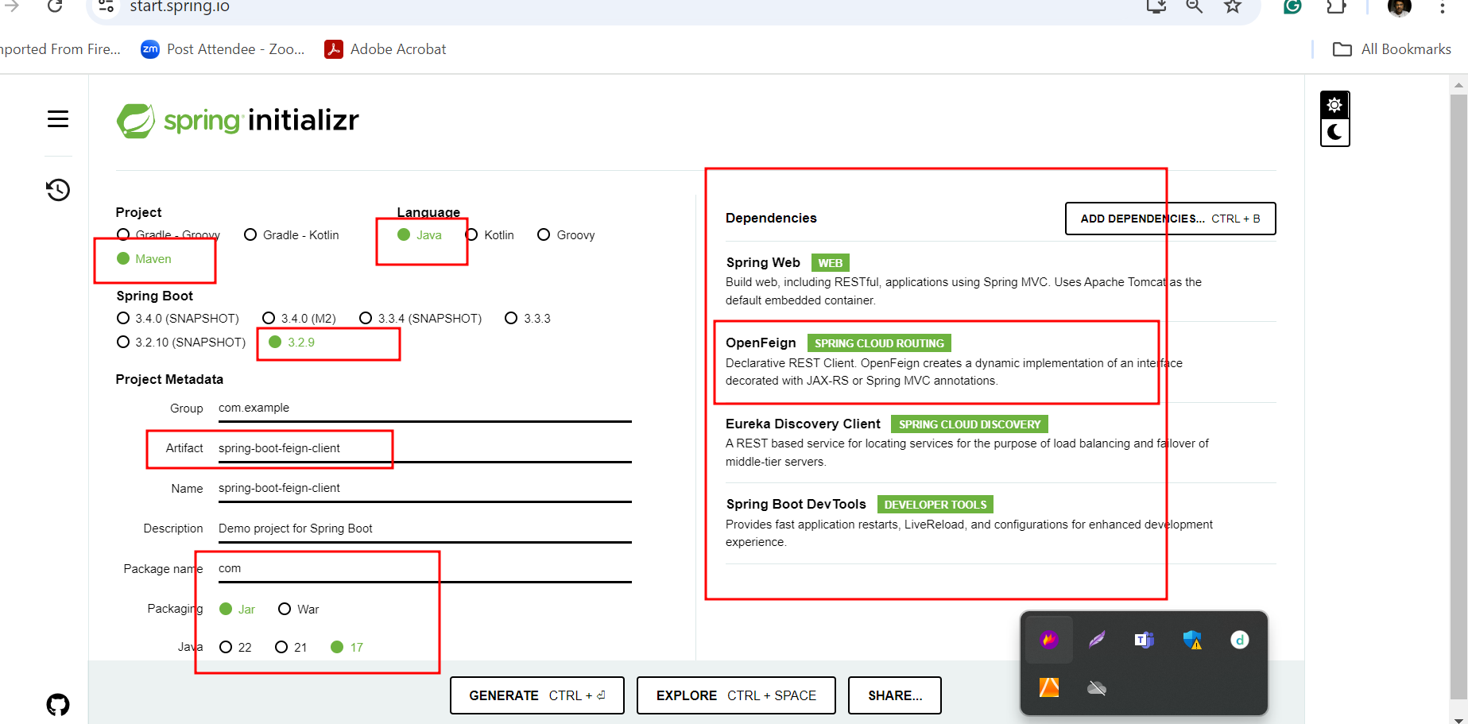

***This application going to communicate with account micro service as well as gpay micro service in declarative manner.***

***API Gateway***

***Api gateway act as a server for frontend technologies. It is use to keep track about all request receiving for all micro service or one rest api.***

***It is use to do some authentication, routing, logging, monitoring api request.***

***This api gateway we can achieve lot of way.***

***In spring boot they provider starter.***

***We can configure api way functionality using***

1. ***Java code***
2. ***Using properties or yaml/yml etc.***

***8761 🡪 eureka server***

***9090 🡪 account micro service db mysql***

***9191 🡪 gpay micro service db h2 in memory db.***

***9292 🡪feign client no db***

***8080 -🡪 Api gatway***

***We write the logic in this app to route the specific micro service.***

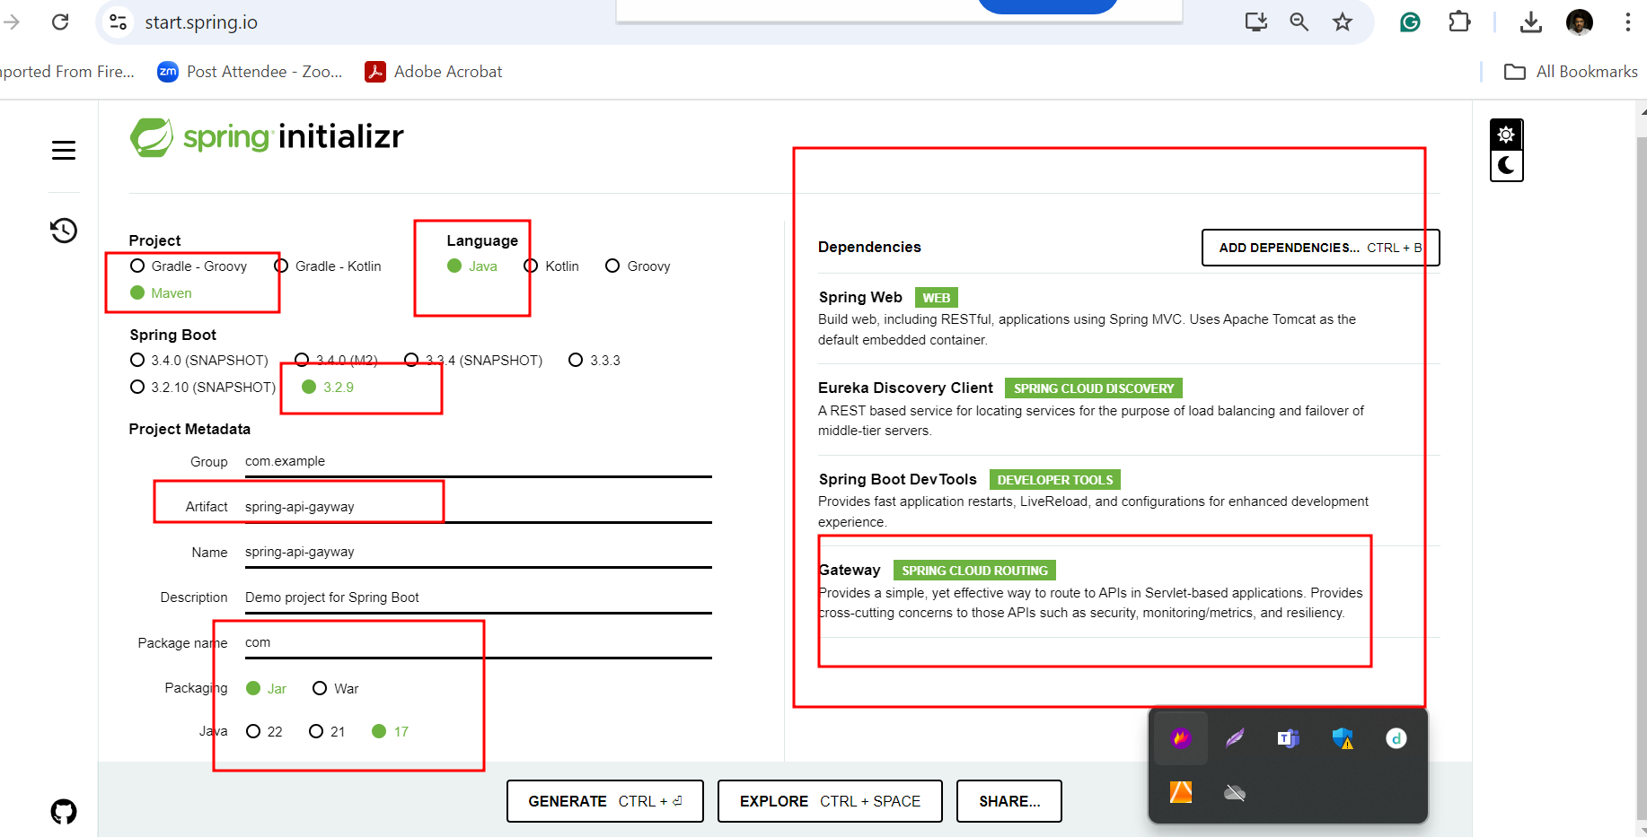

***After project create please open the pom.xml file and verify gateway dependency as***

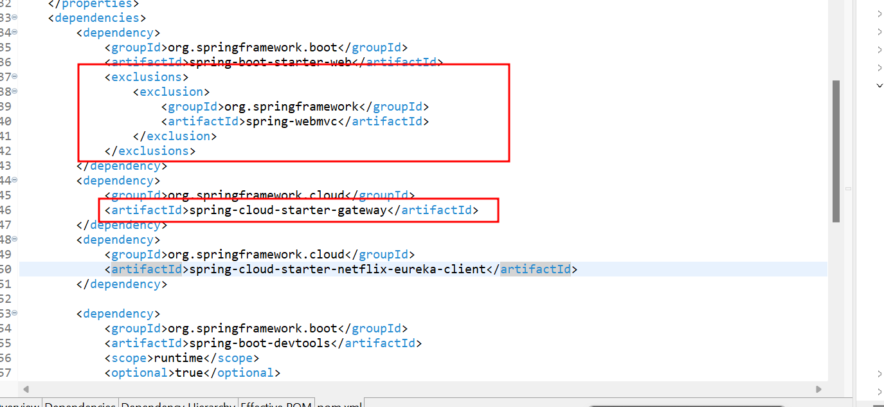

***This project running on default port number 8080.***

***Then in main class write the below***

***Code***

**package** com;

**import** org.springframework.boot.SpringApplication;

**import** org.springframework.boot.autoconfigure.SpringBootApplication;

**import** org.springframework.cloud.client.discovery.EnableDiscoveryClient;

**import** org.springframework.cloud.gateway.route.RouteLocator;

**import** org.springframework.cloud.gateway.route.builder.RouteLocatorBuilder;

**import** org.springframework.context.annotation.Bean;

@SpringBootApplication

@EnableDiscoveryClient

**public** **class** SpringApiGaywayApplication {

**public** **static** **void** main(String[] args) {

SpringApplication.*run*(SpringApiGaywayApplication.**class**, args);

System.***err***.println("api gateway running on port number 8080");

}

@Bean

**public** RouteLocator myCustomerLocator(RouteLocatorBuilder builder) {

System.***out***.println("I Came Here");

**return** builder.routes().route(r>r.path("/account/**").and().method("GET").uri("http://localhost:9090")).build();

}

}